Carl de Witt u21444928 prac 4

Task1

* 1. the code compiled in the program but it did not execute due to a floating point exception and more specifically an arithmetic error the line at which the error was found is at line 13 which calls the function to execute and the functions return is where the error occurs so in line 19. The reason for the error is that the divider is -2 and it is being divided by 0 which cant be done thus the error.
  2. The memory leak is because you make it index 10 you can stop this from happening by just null checking alles.

40 bytes are lost because each index is 4 bytes and we made 10 of them thus 40 is the number

PID = 345

Invalid write of size 4

Task2

2.1) the first design patterns combination that you could use is composite and decorator design patterns. Your composite would mainly be out of Folder and file and the context would be node. And then you could make it so that the decorator makes the filetypes. So, for example it would decide to give you a .cpp file which has certain functionality. The next pair of combinations you could have used is composite and template method it would work the same as the4 decorator file but this time you would create a specific file from the beginning and the template pattern would go and create your special file based on what you wanted to create

2.2) template method with composite

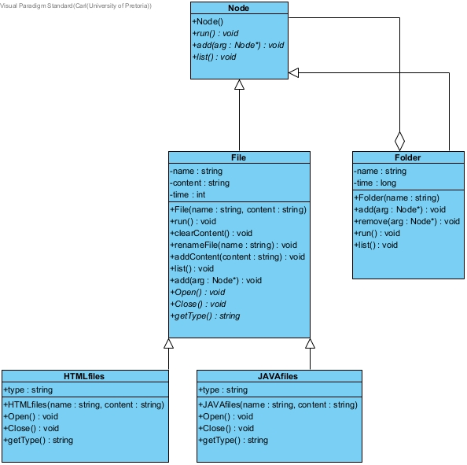

2.3) implemented

Task 3

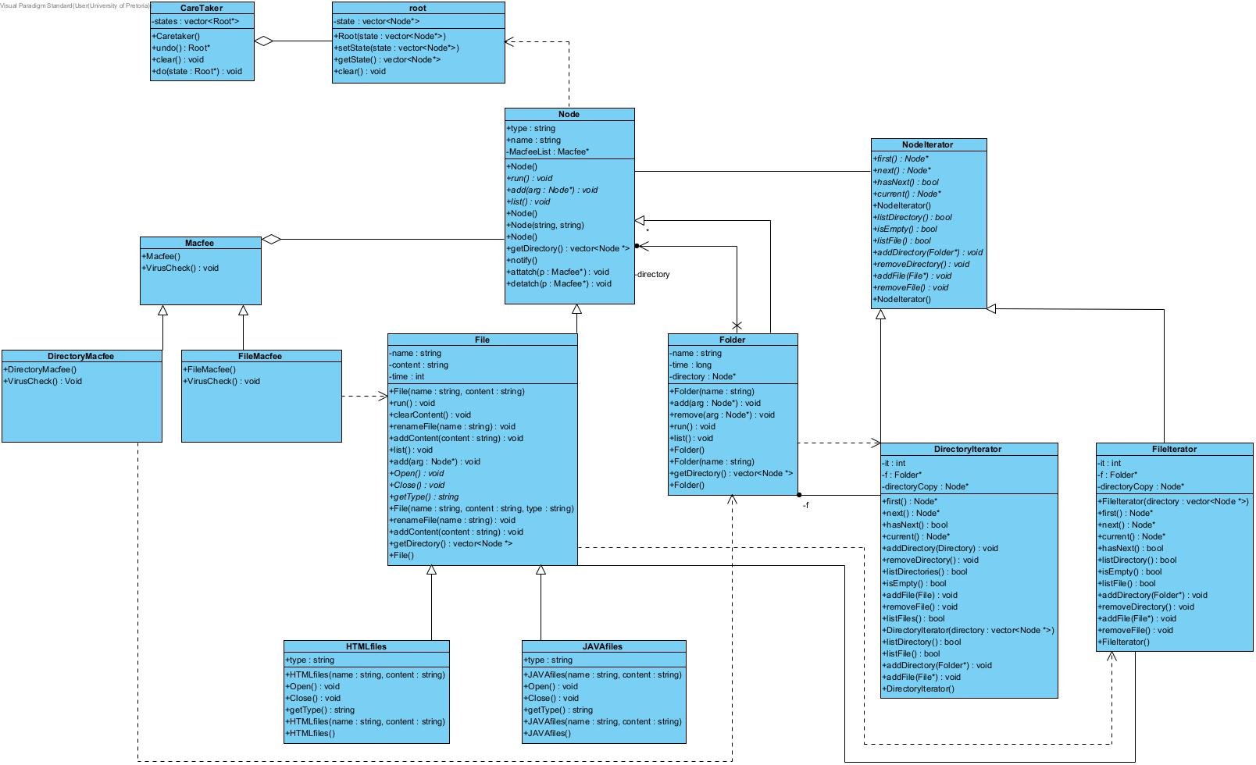

Task 4

4.3 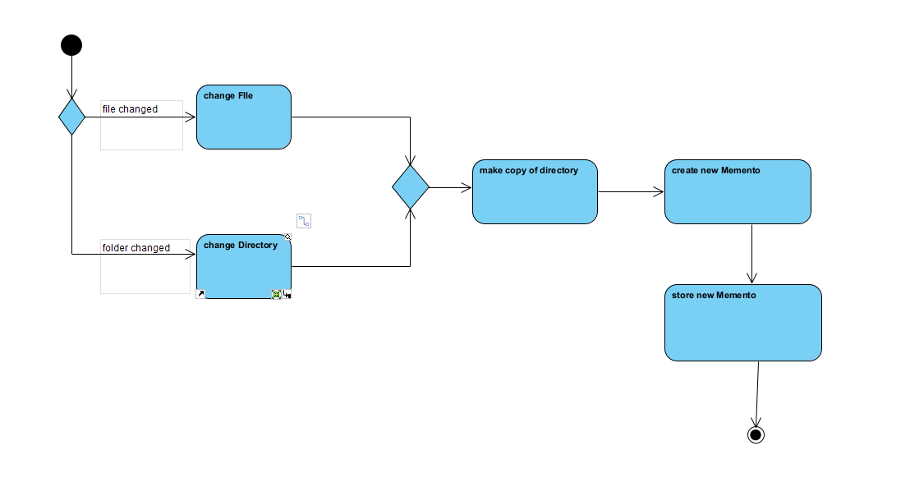

Task 5

5.3) 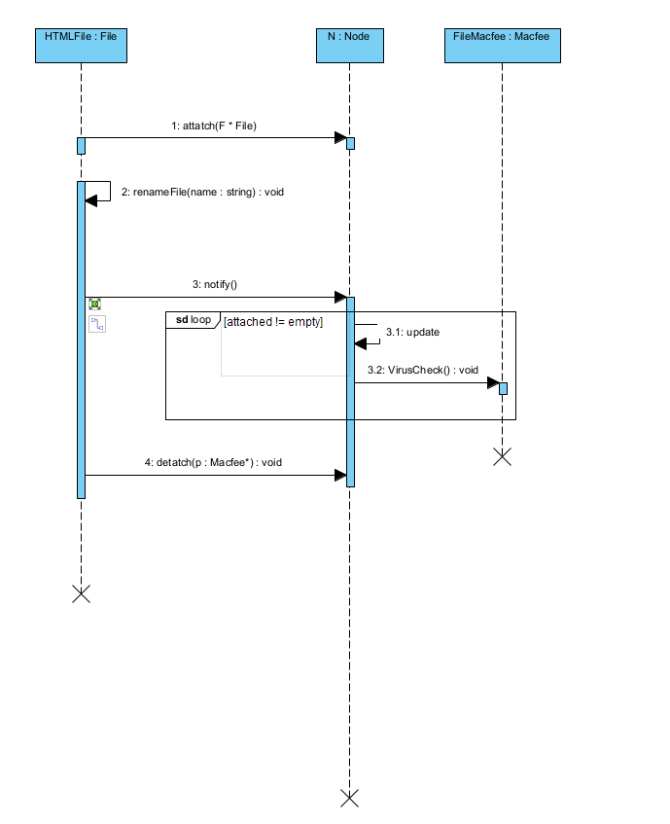

Task 7